**Sample Homework Submission**

**Homework 1 – Stat 5100**

**Brennan Bean (9/4/2019)**

**Problem 1**

**Part a:**

Notice how both “Problem 1” and “Part a” are listed on their own lines and bolded. This will be helpful to the grader as they navigate through your submission. This will also be helpful to you as you work on pieces of the homework throughout the week. With the exception of Homework 1, it is strongly recommended that you work on these assignments one piece at a time.

**Part b:**

Be sure to give every figure a caption and be sure to reference each figure in the text. This is a great way to determine which output is relevant and which is not: if you don’t have a need to reference the figure in the text, then it is probably not relevant for the submission. For example, Figure 1 shows a nice looking set of scatterplots, while Figure 2 shows a nice looking map. Notice that the order of the figures matches the order in which I referenced them in the text.

Three scatterplots of design snow load against elevation. 


Figure 1: Plots of elevation against design ground snow load (log scale) for three select datasets in the Northwest United States.

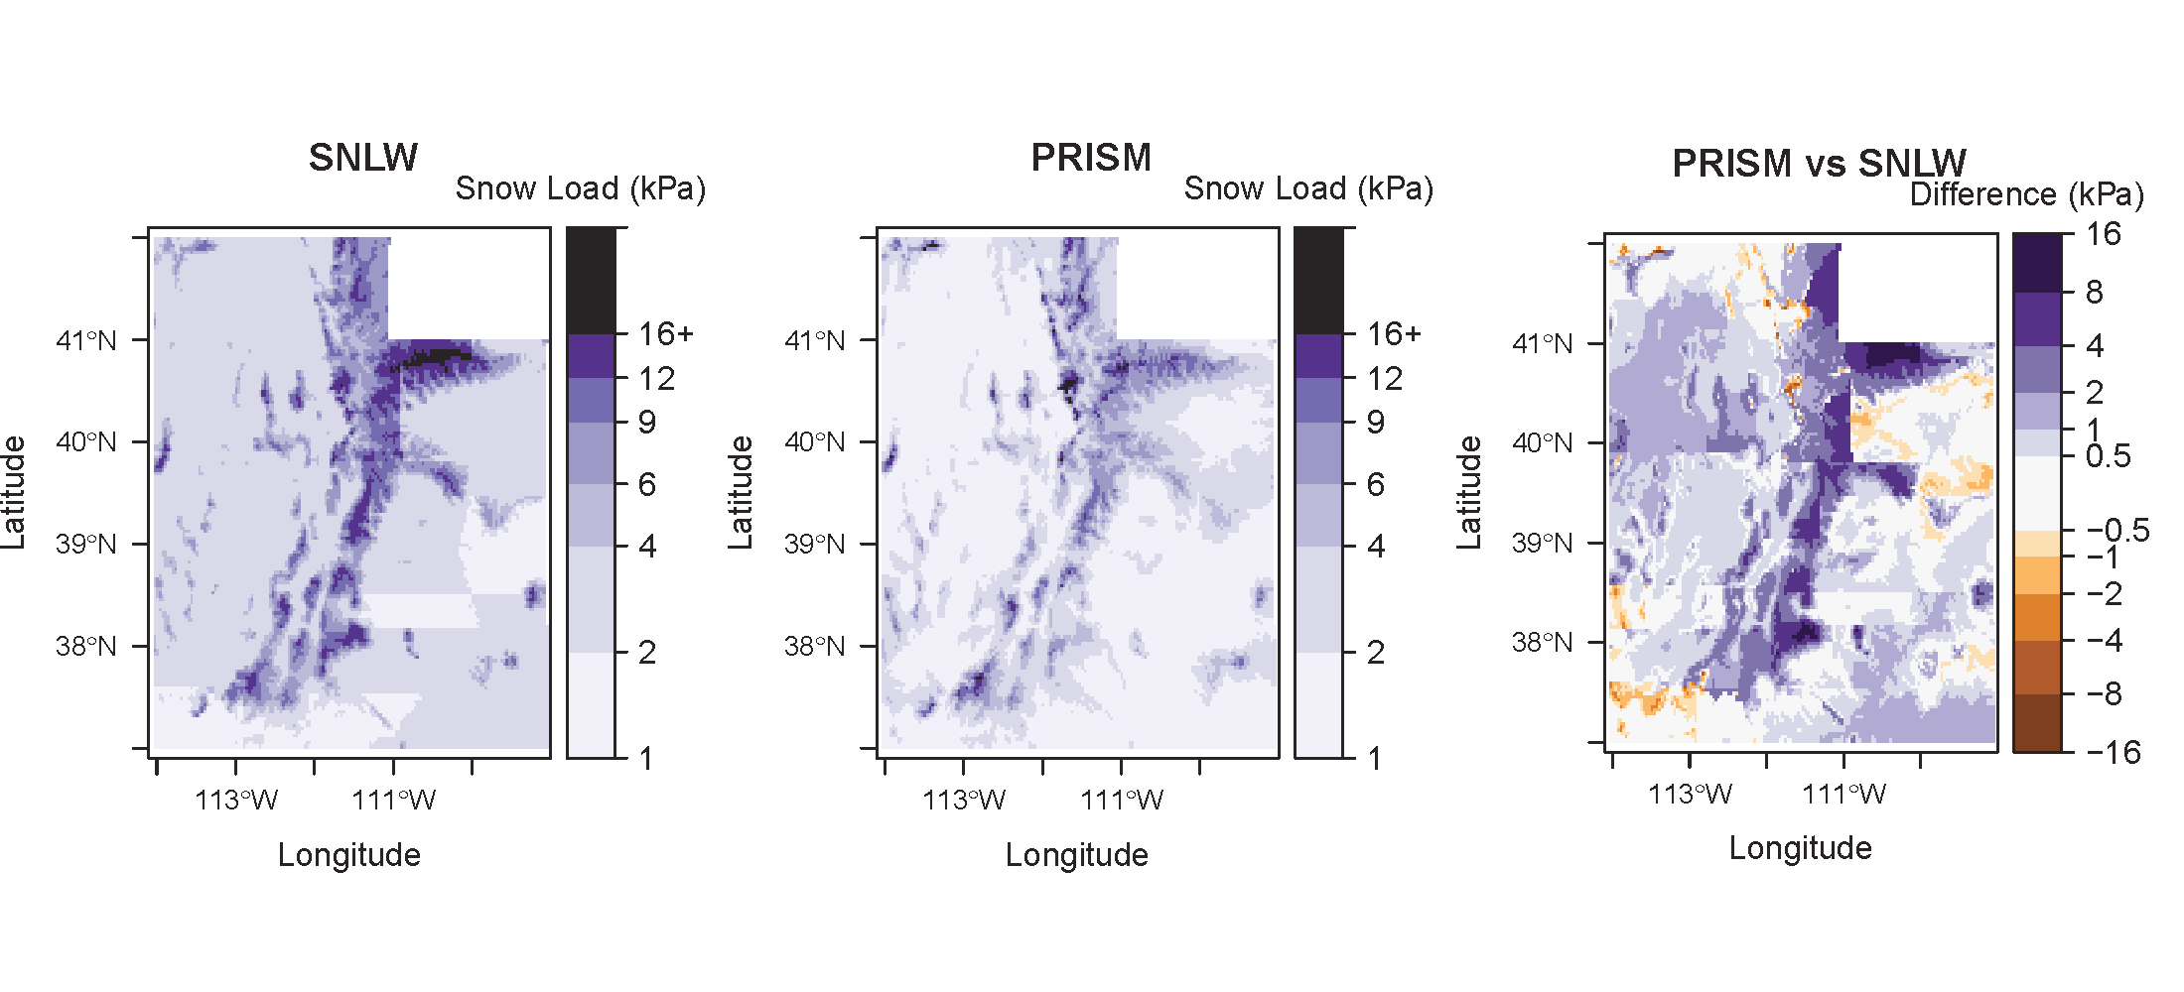

Figure 2: Maps of design ground snow load predictions for Utah.

**Problem 2:**

**Part a:**

Notice the large amount of white space between the end of Problem 1 and the start of Problem 2. This is because each problem needs to start on its own page. This would be a waste of space if you were printing the assignment, but remember that all assignments are submitted electronically. This separation is crucial for helping Jared navigate through each problem in the homework.

**Part b:**

Should you choose not to answer a particular problem or problem part, it is courteous (though not required) to indicate this as shown in part c.

**Part c:**

No Answer

**Part d:**

Please post any questions about this homework sample on Piazza. Also be sure to continue scrolling to see the guidelines for the code appendix.

‘

**Appendix – SAS Code**

**Problem 1**

/* Complete SAS code for STAT 5100 Homework 1 */

/* Enter Data */

data reading;

input Method $ CompChange @@;

cards;

Basal 1 Basal 1.5 Basal -2.5 Basal -2.5 Basal -1 Basal -5.5

Basal -2.5 Basal -4.5 Basal 0 Basal -1 Basal -2 Basal -1.5

Basal -3.5 Basal 1 Basal -2 Basal -0.5 Basal -3.5 Basal -3.5

Basal -2.5 Basal -3.5 Basal -0.5 Basal 0 DRTA 2 DRTA -1

DRTA 0 DRTA 0.5 DRTA -1.5 DRTA -1 DRTA 2 DRTA 1.5

DRTA -0.5 DRTA -1.5 DRTA 0 DRTA -0.5 DRTA 2 DRTA -0.5

DRTA 1 DRTA 4.5 DRTA 2 DRTA -1.5 DRTA 2.5 DRTA 0.5

DRTA 1.5 DRTA 1

;

run;

/* Compare two groups */

proc ttest data=reading;

class Method;

var CompChange;

title1 'Two-group comparison';

run;

**Problem 2**

**(Code is identical to problem 1 as this is merely for illustration. Notice how the code for problem 2 starts on a new page. If a particular problem does not require any code, simply skip it in the appendix.)**

/* Complete SAS code for STAT 5100 Homework 1 */

/* Enter Data */

data reading;

input Method $ CompChange @@;

cards;

Basal 1 Basal 1.5 Basal -2.5 Basal -2.5 Basal -1 Basal -5.5

Basal -2.5 Basal -4.5 Basal 0 Basal -1 Basal -2 Basal -1.5

Basal -3.5 Basal 1 Basal -2 Basal -0.5 Basal -3.5 Basal -3.5

Basal -2.5 Basal -3.5 Basal -0.5 Basal 0 DRTA 2 DRTA -1

DRTA 0 DRTA 0.5 DRTA -1.5 DRTA -1 DRTA 2 DRTA 1.5

DRTA -0.5 DRTA -1.5 DRTA 0 DRTA -0.5 DRTA 2 DRTA -0.5

DRTA 1 DRTA 4.5 DRTA 2 DRTA -1.5 DRTA 2.5 DRTA 0.5

DRTA 1.5 DRTA 1

;

run;

/* Compare two groups */

proc ttest data=reading;

class Method;

var CompChange;

title1 'Two-group comparison';

run;